TAYSIDE MACHINERY LTD
SCOTLAND
TELE: 0044 (0) 1382 200797 FAX: 0044 (0) 1382 202853
e-mail: sales@taysidemachinery.co.uk website: www.taysidemachinery.co.uk

Mazak Integrex 100-IISY (5 axis) CNC Turn / Mill Centre
ST3511

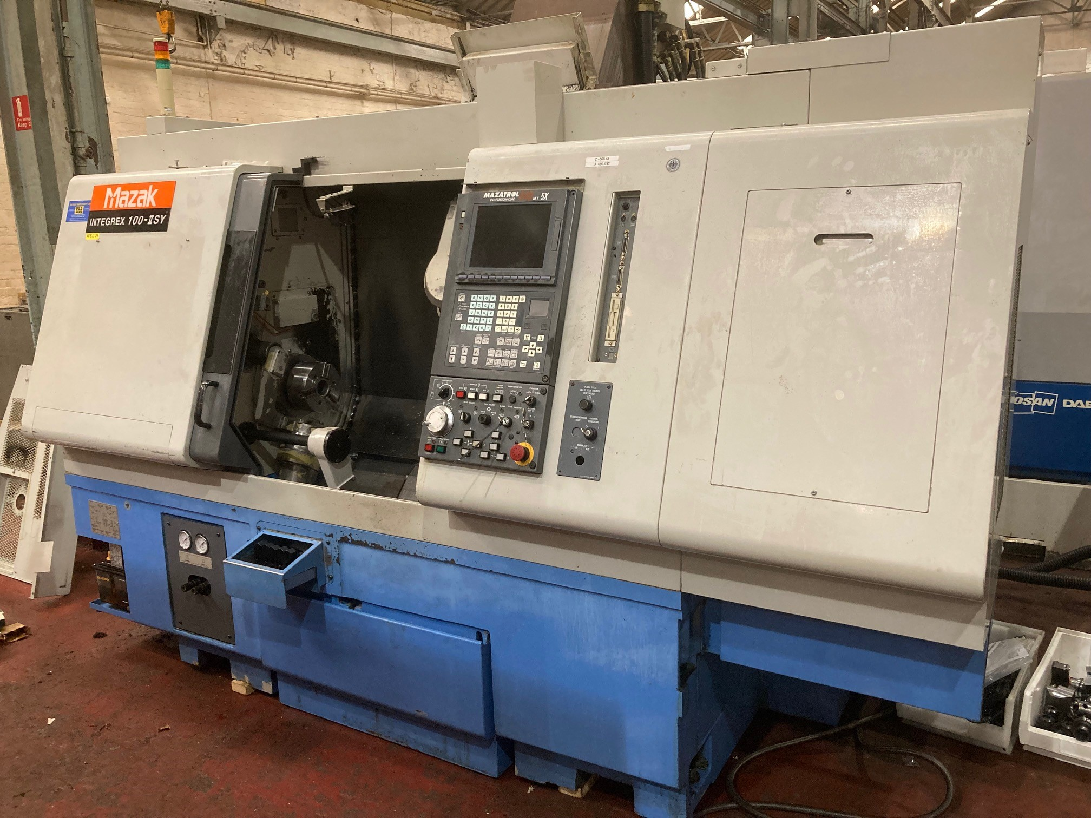

Mazak Integrex 100-IISY CNC Turn / Mill Centre

Model: Integrex 100-IISY
Year: 2002
Control: Mazatrol PC Fusion 640 MT (5 axis)

Max. Turning Dia.: 470mm
Max. cutting length: 753mm

Spindle Speeds: Main: 6000 RPM / Sub: 6000 rpm
Spindle Bore: 51mm

Milling Speed: 10,000 RPM

C axis Main spindle and Sub spindle: 0.001 degree
B axis movement +/- 90 degrees
X axis Travel: 410mm
Y axis Travel: +/- 70 degrees
Z axis Travel: 804mm

Machine with:

20 station toolchanger
Swarf conveyor
Automatic Parts Catcher

